**Popeyes Management App**

IS 436-03 Structured Systems Analysis and Design Project

Deliverable 5: “Closing: User Interface Design, Program design and System

Implementation



Group Members:

Jessica Park

Farah Siddiqui

Betelhem Taddele

Danny Nguyen

Jatin Chauhan

Munam Ghazanfar

Ninh Ngo

Adil Mufti

05/09/2019

**Table of Contents**

Section 1:

Systems Request ………………………………………………………………….. 3

Feasibility Analysis ………………………………………………………………… 5

Team Member Information …………………………………………………....…….. 7

Section 2:

Requirements Definition …………………………………………………………………9

Interviews ………………………………………………………………………………...11

Observations ……………………………………………………………………………16

Document Analysis…….…………………………………………………………………18

Use Cases …………………………………………………………………..……………19

Section 3:

DFD Diagrams ………………………………………………………………………... 29

Text Definitions ………………………………………………………………………….40

Section 4:

ER Diagram …………………………………………………………...………………..…..43

Alternative Matrix…………………………………………………………………………….45

System Architecture Matrix …………………………………………………………………47

Operational Requirements…………………………………………………………………...48

Hardware and Software Specifications ………………………………...…………………50

Section 5:

UI Design………………... ………………………………………….………………………51

Interface Standards ………………………………………………..………………………53

Program Design ………………………………………………………...……………………54

System Requirements …………………………………………..…………………………56

Team Experience…….…………………………………………..……………………………57

Project Plan …………………………………………………………………………...………58

Gantt Chart………………….. …………………………………………………………….…59

**SYSTEMS REQUEST**

**Project Sponsor**

Syed Iqbal, Business Owner

Popeyes Louisiana Kitchen

[meabid@gmail.com](mailto:meabid@gmail.com), [essexpopeyes@gmail.com](mailto:essexpopeyes@gmail.com)

**Business Need:**

Create an app that comprises all the needs of Popeye’s Restaurant to maintain a successful business. The needs of the business are a HACCP log, Daily Food Excellence Audit, Rush-Readiness Checklist, photo uploads for products and sanitation, and the ability to upload business numbers such as sales, labor, and inventory. This app will allow the business owner to log onto the app and complete their daily tasks in an organized comprised manner. Additionally, because the business owner owns more than one restaurant and all of the above requirements are done manually by the managers, an app will allow him to manage his businesses more efficiently and in less time.

**Business Requirements:**

The app/webpage will allow the users to be able to report different problems. It will be very beneficial for the owner to receive up-to date information in an organized form all in one specific space. The specific functionality of this system includes:

* The user can add the financial information sales, labor percentage periodic in the app.
* User can upload the photo of the Products.
* Admin must be able to create multiple users and profile
* User should be able to access a To-do checklist i.e Rush-Readiness checklist,HACCP log and Sanitation practices.
* User should be able to notify the Managers to complete a task which has not been finished yet or incorrectly completed.
* Automated report of all the text and critical instance that occur in each restaurant.
* If the check box for HACCP log that was not checked by 11am, 3pm, 7pm,11pm trigger an email response.
* App should include the speed time of the drive thru and the number of cars per interval.
* Admin should be able to view a summary report of other users to ensure that the assigned task has been completed.

**Business Value:**

In any restaurant there are numerous amounts of safety and health guidelines that a manager must ensure are met daily. Specifically, a manager’s tasks require monitoring and constant supervision to ensure that they meet the requirements set forth by the Health department and by upper management. Seeing as Popeye's guidelines are more stringent than the health department's, it is vital that each individual franchise achieves or supasses each metric daily. To do this, our stakeholder currently requires that each general manager send daily updates through group messages. In order to reduce the amount of clutter and create a more defined output to track all these tasks, he has hired our team to create a web-based application to tackle these duties.

This web-based application will help improve organizational workflow and work efficiency as well as allow managers to focus more of their time on other areas of work. This application is also expected to improve the scores received during inspections by upper management as general practices should be easier to check and follow each day through the use of this application. The value of this application should also generate easier workflow for store managers as there would eventually be a singular, codified outlook in which they can track their daily tasks rather than inputting information through multiple portals. The implementation of this application should positively affect both general managers and the stakeholder immensely in their daily tasks.

**Special Issues or Constraints:**

The manager responsible, must be notified with an automated email response, whenever necessary. The admin should see full information for selected/desired restaurant; also an organized overall summary with up-to-date information in one specific space. Managers must and only be able to upload pictures with an informative title, which should be saved with a username, restaurant location and a timestamp in the database. Therefore, unauthorized access must be able to be prevented or blocked.

Data must be protected from any html or sql injections, and should be encrypted accordingly. Queries to read from database must display information based on the account type. In case of accidental data loss, all data must be able to be backed up in another remote location.

The project is expected to be completed in an year.

**Feasibility Analysis:**

**Technical Feasibility:** A technical risk is that training would be required to use the new application because the managers currently uses email/SMS as a primary source of communication to record data such as profits, inventory, and labor. However, since the application is to be used by only managers, training costs would not be too high since other employees do not have to learn how to use the new system. Furthermore, training cost is not expected to be too high because the app will be user-friendly. The managers are also already familiar with Redbook features, so new technology would include uploading photos and numbers to the web application and navigating the web application. The project size is large because the app needs to be able to combine the work of multiple locations; however, it is not too large to the point where it is unattainable. The current existing system is just email/SMS as stated previously so compatibility should not be an issue.

**Economic Feasibility:**

|  |  |  |  |  |
| --- | --- | --- | --- | --- |
| Cost-Benefit Analysis | First Quarter | Second Quarter | Third Quarter | Fourth Quarter |
| **Benefits** |  |  |  |  |
| Increased Sales |  | 8000 | 8500 | 9000 |
| **Development Costs** |  |  |  |  |
| Server | 2000 | 0 | 0 | 0 |
| Development Labor | 3000 | 0 | 0 | 0 |
| **Total Development Costs** | 5000 | 0 | 0 | 0 |
| **Operational Costs** |  |  |  |  |
| Hardware |  | 800 | 800 | 800 |
| Software |  | 1500 | 1500 | 1500 |
| Software Licensing Fee |  | 1000 | 1000 | 1000 |
| Operational Labor |  | 2500 | 2575 | 2625 |
| Training Cost |  | 500 | 500 | 500 |
| **Total Operational Costs** |  | 5400 | 6375 | 6425 |
| **Total Costs** | 5000 | 5400 | 6375 | 6425 |
| **NPV** | (5000) | 2600 | 2125 | 2575 |

The length of the project will be about one year and the cost-benefit analysis will be divided into four quarters. The first quarter will have a negative net present value (NPV) because the system is still in the development phase, so it will incur costs and no benefits. The remaining three quarters is projected to result in a positive NPV that ultimately makes up for the loss in the first quarter due to the managers having more time to focus on sales and operations rather than collecting and recording Redbook numbers.

**Organizational Feasibility:**

The project goal is to develop an application to provide a more efficient method to monitor and record business numbers and safety/health requirements. This aligns with the business strategy of reducing clutter of data in emails and group messages while simultaneously satisfying health and safety requirements. Implementation of the new system will allow:

* tracking and recording of data through automation rather than by hand
* consistent method of recording data
* easy access to desired business information
* streamline manager responsibilities (salaries, tax payments, etc.)
* managers to focus on other areas in their work

Managers would be receptive to the new system because reducing their time spent on recording Redbook numbers would allow more time to focus on sales and customers.

**Team Member Information:**

|  |  |  |
| --- | --- | --- |
| **Name** | **Contact**  **(Email and Number)** | **Job Title** |
| Danny Nguyen | [Dang6@umbc.edu](mailto:Dang6@umbc.edu)  443-838-0123 | Quality Assurance |
| Jessica Park | [jpark32@umbc.edu](mailto:jpark32@umbc.edu)  443-912-0564 | Project Manager |
| Munam Ghazanfar | [mu4@umbc.edu](mailto:mu4@umbc.edu)  443-425-5544 | Quality Assurance |
| Farah Siddiqui | [farah4@umbc.edu](mailto:farah4@umbc.edu)  443-841-8049 | Business Analyst |
| Jatin Chauhan | [chauhan3@umbc.edu](mailto:chauhan3@umbc.edu)  443-815-8347 | Database Administrator |
| Betelhem Taddele | [be24@umbc.edu](mailto:be24@umbc.edu)  240-899-4304 | System Analyst |
| Ninh Ngo | [lx04615@umbc.edu](mailto:lx04615@umbc.edu)  240-429-2711 | Developer/Programmer |
| Adil Mufti | [amufti2@umbc.edu](mailto:amufti2@umbc.edu)  443-285-3076 | Database Administrator |

**Team Bio:**Jessica Park: I am a senior at UMBC with an expected graduation of Spring 2019 with a major in Information Systems. I plan to find a job in Business Operations, Project Management, or Cybersecurity. My role as a Project Manager is to make sure all of my group members are able to complete their tasks in a timely manner and assisting in all areas as needed and submitting the deliverables on GitHub before the deadline while also being the liaison during communication with the Professor.

Farah Siddiqui: I am a senior at UMBC with an expected graduation date of spring 2019. I would like to work as the Business Analyst. My role in the project is going to be interacts with the business stakeholders and subject matter experts in order to understand their problems and needs. I will be gather all the information from the business and requirement to achieve the goal.

Munam Ghazanfar: I am senior at UMBC with an expected graduation date of Spring 2019. I am majoring in Information Systems. After graduation, I would like to work as a Quality Assurance or System Analyst. My role in this project is to monitor the whole project and make sure there are no mistakes and all the requirements are met.

Jatin Chauhan: I am a senior student at UMBC majoring in Information Systems. I’m expected to graduate after current semester i.e Spring 2019. I’m finding a job in Database Development, Project Management, or Website Development. My role in this project is to create a Database schema and develop Database being a Database Administrator.

Betelhem Taddele: I am a senior at UMBC and expected to graduate in spring 2019 with a degree in Information Systems. After I graduate, I would like to work in system analyst and project management position. My role for this project as a System Analyst is to build structures in the form of Information Systems.

Ninh Ngo: I am a senior at UMBC and major in Information Systems. I am graduating after this spring semester. I hope to get into software development after graduation. Previous experience with software development at internship with My Great Software. My role for this project is developer and helping contribute to all deliverables.

Danny Nguyen: I am a senior at UMBC within the Information Systems school. I will be graduating in the Fall of 19’ and I hope to begin my career in computer networking upon graduation. I have previously worked at HRSA under a Pathways and hope to continue my career in civil service as I felt nothing but positivity through my experiences.

**Meeting Time:**

All our group members have different class schedules and it was difficult to just pick one specific day and time for all seven of us to meet and discuss about the project. Therefore, each member listed their availabilities, and based on that we break our meeting times into three different days, so each person can pick any day within the specific time that suits perfectly to their schedule.

|  |  |  |
| --- | --- | --- |
| **TEAM MEETING TIMES** | | |
| **TUESDAY** | **WEDNESDAY** | **THURSDAY** |
| **4-6PM** | **11:30-2:30PM** | **3:30-4:30PM** |

**Requirements Definition**

Functional Requirements:

Process-Oriented:

1. System must be able to store a large amount of data in a database
2. Must have the ability to upload photos
3. Must be able to create a checklist system such as to-do checklist or rush-readiness checklist
4. Communication must be available to other users within the app
5. System must be able to create critical reports and have the ability to show a summary report
6. Must be able to set reminders for users when jobs are not completed

Information-Oriented:

1. Must be able to store financial information such as sales, labor percentage periodic and photos of products
2. Store times and number of cars per interval that use the drive-thru
3. The system must store all information for a minimum of 3 years.

Non-functional Requirements:

Operational:

1. The system will be able to run on both android and apple devices
2. Should be able to integrate with the existing inventory system as well as the finance recording system
3. Should be able to backup all files to a secondary drive or cloud storage

Performance:

1. The system should have at least 500 Gb of memory storage and respond to system owner requests in an efficient manner, depending on the depth of the function.
2. The system should be available during all hours of a routine work day; costs can be saved by turning off the system during certain hours (0000 - 0800).
3. The system should support up to 10 users at a time doing various tasks, with scalability in mine for future use.
4. The network bandwidth should be rated for 1 Gbps.

Security:

1. All login and passwords that are sent through the network should be encrypted when stored.
2. System should include all available safeguards from viruses, worms, Trojan horses, etc.
3. The backups should be stored in 2 locations, on the cloud for quick access and within a locked storage area.
4. No users shall be created for employees that are non-managers unless authorized by system owner.

Cultural/Political:

1. Managers shall only be able to view information about their own store.

Interview #1:

Name of Interviewee: Syed Abid Iqbal

Position of Interviewee: Owner

Date & Time of Interview: 3/23/2019

Name of Interviewer: Farah Siddiqui

Purpose of Interview:

* Understand the current process of their transition of information.
* Determine the requirements for the future system.
* Gain insight on what Mr. Iqbal needs to needs to be improved, and what additional thoughts he had on our proposed system.

**Open Items:** Schedule an interview with Abdelilah Moustafeh regarding an owner’s perspective and what he would like to be improved.

**Detailed Notes:**

* Syed Iqbal is the owner of five different location of Popeyes. He is interested in creating web application that will give an opportunity to have all this financial information of his business in one platform.
* All the location they currently use the traditional excel, and paper form. All of the log they currently use are on paper which is kept in the office in folder. The business doesn't seems to organized. He is looking to improve his business give his manager extra help by making things easier for them.
* The businesses currently have Sicom as their point of sale which is gives the manager the opportunity to monitor their number. However, there is no system for budgeting. The most of the conversion among managers is done via group chat.

**Summary of interview:**

Mr.Iqbal expressed his concern regarding:

* Lack of the ability to data on time.
* Gather information is very time consuming.
* When Manager miss a task such as, not doing HACCP log can cause risk the consumer healths.
* If Manager fail to report the accurate information on time it cause him to lose money.

**List of Questions:**

**Q.** What is the current process you are using to share and the gather data?

**A.** All of our conversion and information is shared via group chat which is not efficient.

**Q.** How often do you face problem with your current system?

**A.** He stated,” I face many problems. Sometimes the managers do not send the number on time without asking them. Most of the time number are not accurate, or something is always missing”. He said it is very hard for him to find the data that they in conversation which can be very confusing and time consuming.

**Q.** What are the requirements for the future system?

**A.** Iqbal wants website or app which comprises all the needs of business. He wants a simple checklist form which are checked off by managers from all his different store.The checklist should include the HACCP log, Daily Food Excellence Audit, Rush-Readiness. If Haccp log checkbox that was not checked. It should trigger an email response. The manager should be able to upload numbers such sales,labor and speed of drive thru. Also, the manager should be able to upload pictures. Automated report of all the text and critical instance that occur in each restaurant.

**Q.** Do you want manager to share the sensitive information such as, credit card information?

**A.** No, he doesn't want his manager to send sensitive information such as credit card information. The number should be taken by manager from POS system which does not distinguish any credit card information.The web application should ensure security of customer details especially financial details. The card number can be only be read at the Point of Sale system to maintain autonomy.

**Q.** What are privileges that managers will have or they allowed to make changes?

**A.** The manager should to be able share, upload, view and edit the data.However, the Admin should be only be able to create username and password.Admin should be able to view a summary report of all users to ensure that the assigned task has been completed.

**Q**.What are some of the benefits that do you anticipate for the managers as supported by the web application?

A.It should require the managers to be able to share, upload, view and edit the data. However, the application should give only the administrator rights to create usernames and passwords while generating a summary report of all users.

**Q.** How many user account do you need?

**A.** Every store have five manager, so at least 15 accounts.

**Q.** How long you want the data to be stored?

**A.** I will require the data for comparison to get a summary of how many customers we have and their purchasing patterns.

**Q.** Will the user require the training?

**A.** Yes, they will require basic training on how to use the system.

**Interview #2:**

Name of Interviewee: Melissa Howell

Position of Interviewee: Manager

Date & Time of Interview: 3/24/19

Name of Interviewer: Adil Mufti

**Purpose of Interview:**

* The day to day tasks that a manager deals with and what may be challenging.
* What functions and features would be convenient to have on the application from a managers point of view.
* The organization skills that are currently in place with documents and important files.

**Summary of Interview:**

Melissa mentioned how:

* it is a hassle for them to keep track of previous documents because it wasn’t paperless.
* communication between managers could be stronger because they currently use their smartphone in a group chat.
* ensuring that the staff is completing their tasks was stressful to handle so the use of the checklist will help ensure everyone is doing what they need to before they leave.

**Open Items**:

Schedule an interview with the store manager, Melissa Howell to find out how things are currently being kept up with as well as implementations that will helpful.

**Detailed Notes:**

* Melissa is the manager at the Essex location and works 40 hours a week. She spends most of her time taking care of tasks related to the business in the earlier part of her shifts, and then assists customers with her team.
* They use paper to create schedules and many of the other documents are kept in a binder which can easily be lost and it is harder to navigate throughout time.
* Paperwork can get lost as time goes by since everything is physically kept in a binder.

**List of Questions:**

**Q.** How long have you been working at Popeyes?

**A.** I started working at Popeyes as a part-time crew member four years ago and worked my way up to Store Manager within my second year.

**Q.** What is the most challenging task you have to deal with as a manager?

**A.** As a manager, I would say the most difficult task I partake in would have to be making sure crew members are on time and doing their job correctly. If they are doing what they’re supposed to then it allows me to focus on internal needs for the business much efficiently. Also, the ordering procedure for supplies is quite time consuming so a

**Q.** How do you keep track of schedules/ create schedules? Any difficulties?

**A.** Currently, schedules are made on paper and put into a binder which we keep in the backroom. It can be hassle when that binder builds up throughout time because if we needed to go back and see who worked on a particular day it requires me to manually look through hundreds of sheets.

**Q.** How many staff members do you have? Is this amount consistent?

**A.** Our location consists of 20-30 employees with 7-8 employees per shift. During slow hours we try to limit the amount of employees hired due to the slow business.

**Q.** What type of organization method do you use for orders, budgets, inspections?

**A.** All documents regarding important information of the business is kept in a binder just like what we have for the schedules. When the owner comes and visits our location that is one of the major things he checks and it is also a necessity for us to have incase of any emergencies.

**Q.** As a manager, what sort of features would be helpful in an application for you?

**A.** Since most of our documents are on paper it would be relatively convenient for us to have documents that are paperless. This saves time for me looking through a binder. Another feature that would be great would be a way for manager to easily get in touch with other managers in the district.

**Q.** How often would you have to work at other Popeyes location?

**A.** For the most part, I stay at the location I was hired at but there are times when a manager calls out at another location and coverage is needed (especially weekends).

Observations:

This restaurant popeyes is located at Essex,MD. This Popeyes location has lobby for 45 people. When entering the restaurant, the customers’ first interaction is with the cashier. There is an office located on the right side of the restaurant which includes a set up for important documents and folders and all the incoming mails and invoices are stored in there as well. The daily operation includes doing HACCP logs, rush readiness checklist and Daily Food Excellence Audit. The staff records all of these activities in the red book. Red book is a managers book which tracks and analyze daily operations anytime and anywhere and creates tasks as managers do their walk-throughs. On the left side of the drive-thru window, there is a monitor which records the speed of the drive-thru. Most of the communication among the management team is done via iMessage group.

Questionnaire**:**

1. On a scale of 1 to 10, kindly rate how group chat has been useful to you.

Decreasing ← 1,2,3,4,5,6,7,8,9,10 →Increasing

2. Since now you use group chat for information sharing, how likely are you to recommend it to other managers?

1.not likely

2. Less likely

3. Likely

4. Somehow likely

5. Highly likely

3. How good can a website application solve the current problem

A. N/A Poor

B. Good

C. Very Good

D. Excellent

4. A good website application protects consumer details. Kindly agree or disagree.

1. Strongly disagree

2. Slightly Disagree

3. Disagree

4. Agree

5. Slightly Agree

6. Strongly Agree

5. Pick how many user accounts the web application should support

1. *Less than 5*

2. *Between 6 and 10*

3. *Between 11 and 15*

4. *More than 15*

6. How many months that the web application should store the information

1*. Less than 3 months*

2. *Up-to six months*

3*. Up-to nine months*

4. *Up-to 12 months.*

7.How well are the staff able to use the application without training?

A. N/A Poor

B. Good

C. Very Good.

D. Excellent

Document Analysis:

A website application for Popeyes Restaurant requires identification of user requirements, functionalities and features that should be incorporated as per the survey done on the site. After an interview with the manager, it was determined that the food chain owns five food stores and each store is under the similar chain of management. This suggests that the application will be used by all store managers who shall use the platform to send daily reports to a centralized management.

The general manager offered information regarding the requirements of the website application. As a result, literature analysis will be conducted to understand how to incorporate the user requirements in a web application for efficient management. In addition, literature regarding all the financial of store details shall be analyzed to ensure that security is at maximum.

Use Cases:

|  |  |  |
| --- | --- | --- |
| **Use Case Name:** Create Account | **ID:** 1 | **Priority:** High |
| **Actor**: Manager, Owner | | |
| **Description**: Allows manager or owner to create an account with a username and password | | |
| **Trigger:** Owner or a manager interacts with the system for the first time. A new manager is hired  **Trigger Type**: External | | |
| **Preconditions:** User’s first time interacting with the system and does not have an account yet | | |
| **Normal Course:** User creates unique username and password to be used to validate credentials every time the user logs in to the system | | |
| **Postconditions:** User will have a username and password that they need to enter each time they want to log in | | |
| **Exceptions:** E1: Username is unavailable   1. System prompts user to select a different username   E2: Password is too weak   1. System prompts user to select a stronger password | | |

|  |  |  |
| --- | --- | --- |
| **Use Case Name:** Log-in | **ID:** 2 | **Priority:** High |
| **Actor**: Manager, Owner | | |
| **Description**: Manager or owner needs to enter credentials to access system | | |
| **Trigger:** User needs to interact with a feature/function of the system  **Trigger Type**: External | | |
| **Preconditions:** User has previously created an account | | |
| **Normal Course:** User enters the same unique username and password that they previously used to create his or her account | | |
| **Postconditions:** System validates user and user is able to access the system’s remaining features | | |
| **Exceptions:** E1: Invalid credentials   1. User will not be able to access system   E2: Former manager  1. User will not be able to access system | | |

|  |  |  |
| --- | --- | --- |
| **Use Case Name:** Input Financial Information | **ID:** 3 | **Priority:** High |
| **Actor**: Manager, Owner | | |
| **Description**: Allows user to add the financial information sales, labor percentage periodic | | |
| **Trigger:** Manager needs to record financial numbers  **Trigger Type**: External | | |
| **Preconditions:** User is logged in to the system | | |
| **Normal Course:** User enters financial information sales, labor percentage periodic to be stored in system and viewed by owner | | |
| **Postconditions:** Information sales and labor percentage periodic are stored | | |
| **Exceptions:** E1: Invalid input (symbols, letters)   1. System prompts user to enter number values | | |

|  |  |  |
| --- | --- | --- |
| **Use Case Name:** Upload Photo | **ID:** 4 | **Priority:** Medium |
| **Actor**: Manager, Owner | | |
| **Description**: Allows user to upload image of a product or area in a restaurant | | |
| **Trigger:** User needs to provide a visual representation of an incident or product that needs to be reported to the owner  **Trigger Type**: External | | |
| **Preconditions:** 1. User is logged in to the system  2. User has taken the photo | | |
| **Normal Course:** User uploads photo from their device to the system and provides a brief description | | |
| **Postconditions:** The desired photo is uploaded and can be seen by owner | | |
| **Exceptions:** E1: User attempts to upload an incompatible file type   1. System prompts user to upload a file that is supported (png, gif, etc.) | | |

|  |  |  |
| --- | --- | --- |
| **Use Case Name:** Create to-do checklist | **ID:** 5 | **Priority:** Medium |
| **Actor**: Manager, Owner | | |
| **Description**: Allows user to create and access checklist to complete and manage separate tasks | | |
| **Trigger:** User needs to have a visual representation of his or her incomplete and completed tasks for the day/work period  **Trigger Type**: External | | |
| **Preconditions:** 1. User is logged in to the system  2. User has taken the photo | | |
| **Normal Course:** User enters input for each task that are then put into a to-do list | | |
| **Postconditions:** System displays a checklist containing separate tasks that the user can mark under “to-do” or “completed” | | |
| **Exceptions:** No exceptions | | |

|  |  |  |
| --- | --- | --- |
| **Use Case Name:** Message other managers | **ID:** 6 | **Priority:** High |
| **Actor**: Manager, Owner | | |
| **Description**: Allows users to communicate with other managers using the system in order to complete a certain tasks | | |
| **Trigger:** A task was incomplete or done incorrectly, or a new task comes up that needs to be completed  **Trigger Type**: External | | |
| **Preconditions:** User is logged in to the system | | |
| **Normal Course:** User inputs a message that can be sent to another user of his or her choice | | |
| **Postconditions:** Other manager(s) receive notification that displays the message. Sender receives an alert to confirm message was sent | | |
| **Exceptions:** E1: No internet connection   1. System alerts user that an internet connection is required and that message failed to send | | |

|  |  |  |
| --- | --- | --- |
| **Use Case Name:** Store and Display Drive-thru Data | **ID:** 7 | **Priority:** Medium |
| **Actor**: Manager, Owner | | |
| **Description**: Allows users to enter times and number of cars per interval that go through the drive-thru | | |
| **Trigger:** Company wants to collect data on drive-thru efficiency  **Trigger Type**: External | | |
| **Preconditions:** 1. User is logged in to the system  2. Drive-thru data has already been recorded by separate  system | | |
| **Normal Course:** User inputs data into system that was recorded from the other system that collects drive-thru data | | |
| **Postconditions:** Displays drive-thru data separated by time intervals and days | | |
| **Exceptions:** No exceptions | | |

|  |  |  |
| --- | --- | --- |
| **Use Case Name:** Create Critical Reports | **ID:** 8 | **Priority:** High |
| **Actor**: Manager, Owner | | |
| **Description**: Allows creation of reports on all the text and critical instances that occur in each restaurant | | |
| **Trigger:** An incident occurs in a restaurant that requires immediate notification to other managers or to the owner  **Trigger Type**: External | | |
| **Preconditions:** User is logged in to the system | | |
| **Normal Course:** User writes report in system that will be sent to desired recipient | | |
| **Postconditions:** Critical report displayed and recipient(s) can access its contents | | |
| **Exceptions:** No exceptions | | |

|  |  |  |
| --- | --- | --- |
| **Use Case Name:** Display Summary Reports | **ID:** 9 | **Priority:** High |
| **Actor**: Manager, Owner | | |
| **Description**: Allows owner to view summary report of other users’ entered data and completed assigned tasks | | |
| **Trigger:** Owner needs to view managers’ progress and reports  **Trigger Type**: External | | |
| **Preconditions:** 1. Owner is logged in to the system  2. Managers have uploaded financial numbers, photos,  and reports | | |
| **Normal Course:** Owner selects “summary report” to view summary of all information entered for the day | | |
| **Postconditions:** Summary report displayed showing all of the other managers’ activities and inputs into the system | | |
| **Exceptions:** No exceptions | | |

Use Case Diagram:

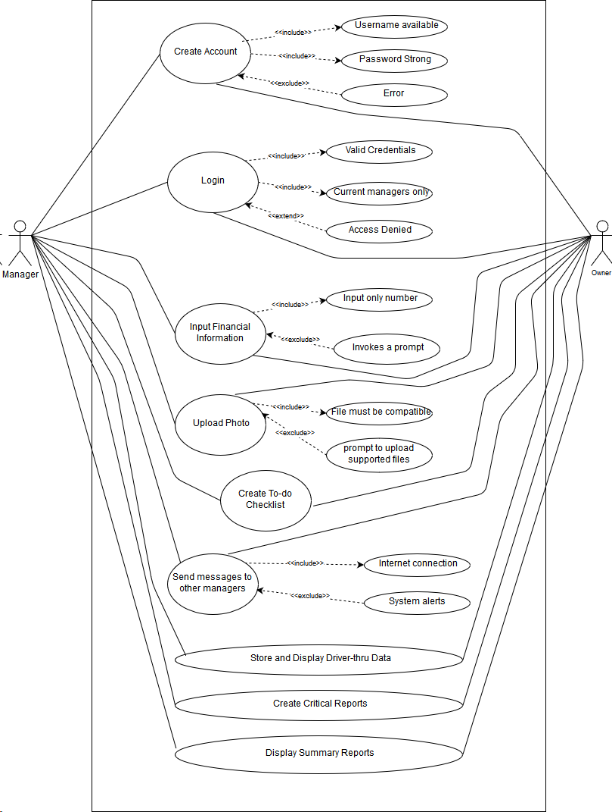

Popeyes Management App

**Figure 3.1 Document Tracking System Context Diagram**

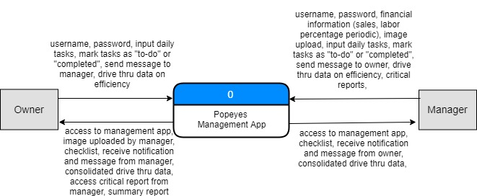

**Figure 3.2 Level 0 DFD**

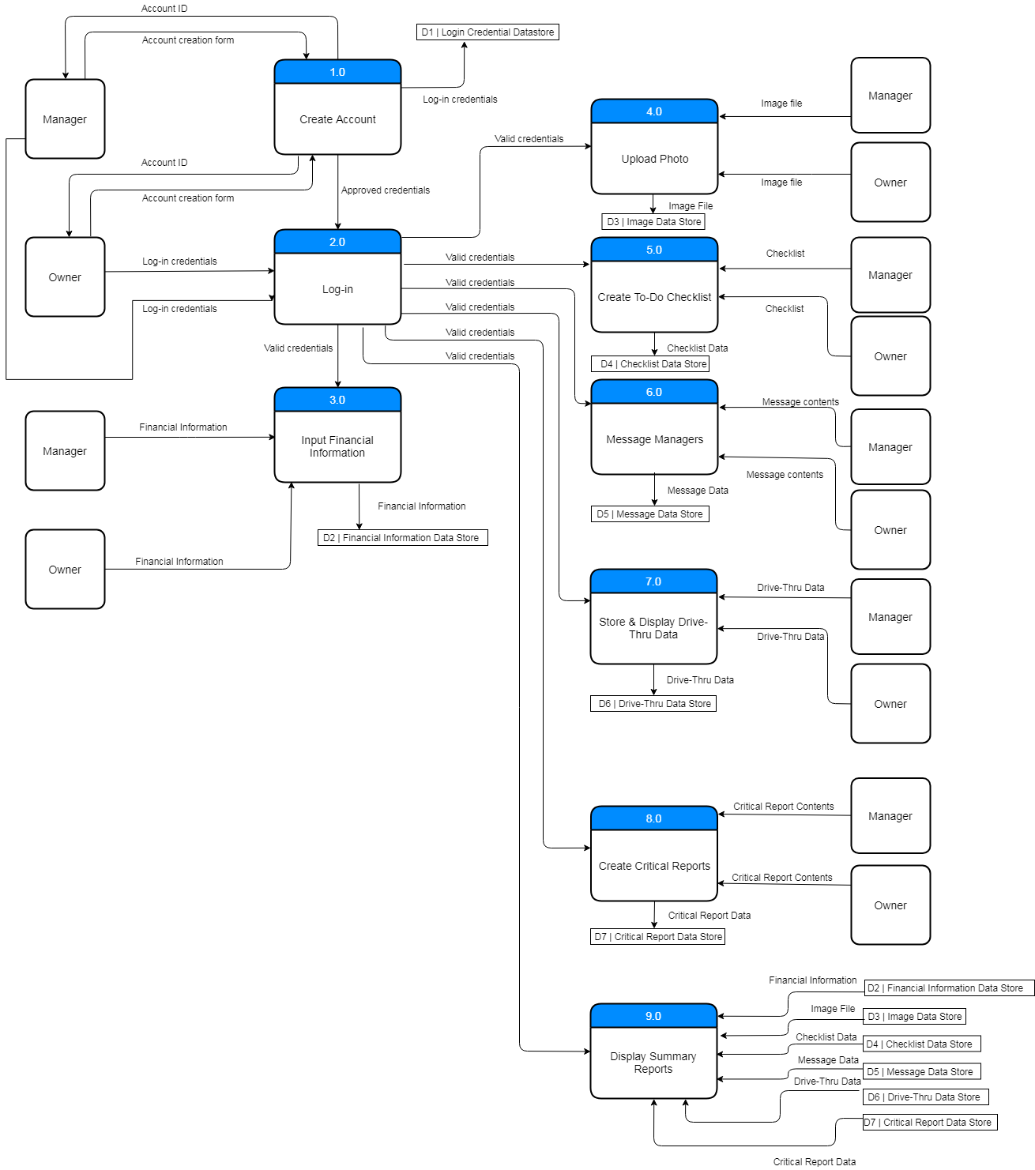

**Figure 3.3 Child Diagram 1 (Create Account)**

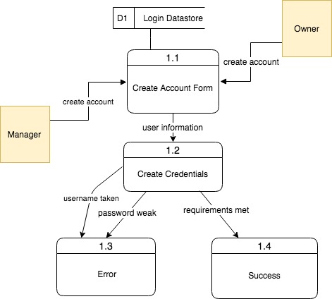

**Figure 3.4 Child Diagram 2 (Log In)**

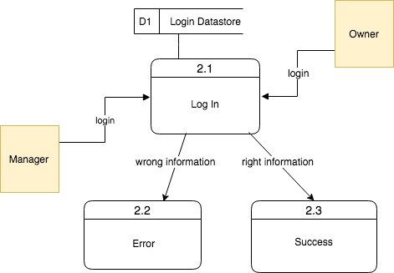

**Figure 3.5 Child Diagram 3 (Input financial information)**

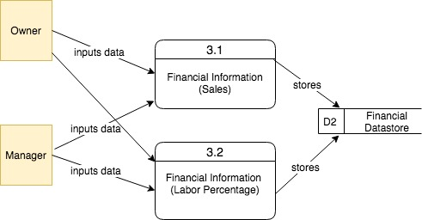

**Figure 3.6 Child Diagram 4 (Image Uploads)**

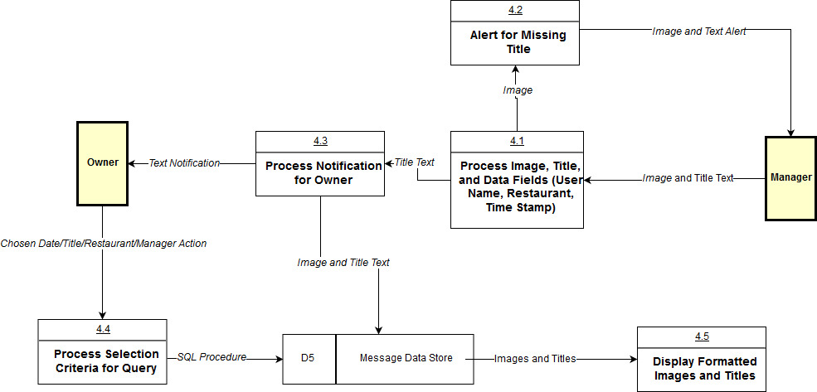

**Figure 3.7 Child Diagram 5 (To-Do Checklist Process)**

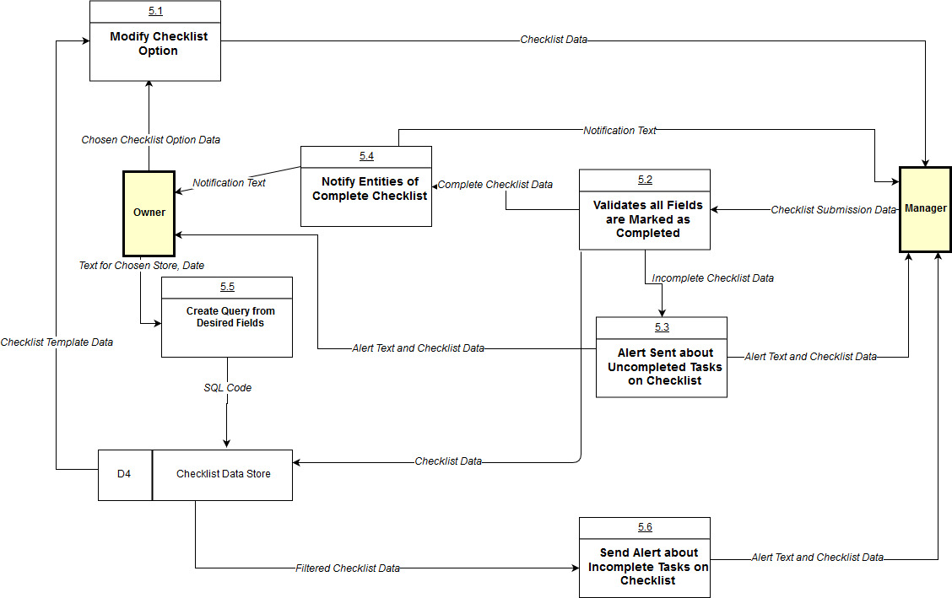

**Figure 3.8 Child Diagram 6 (Messenger Process)**

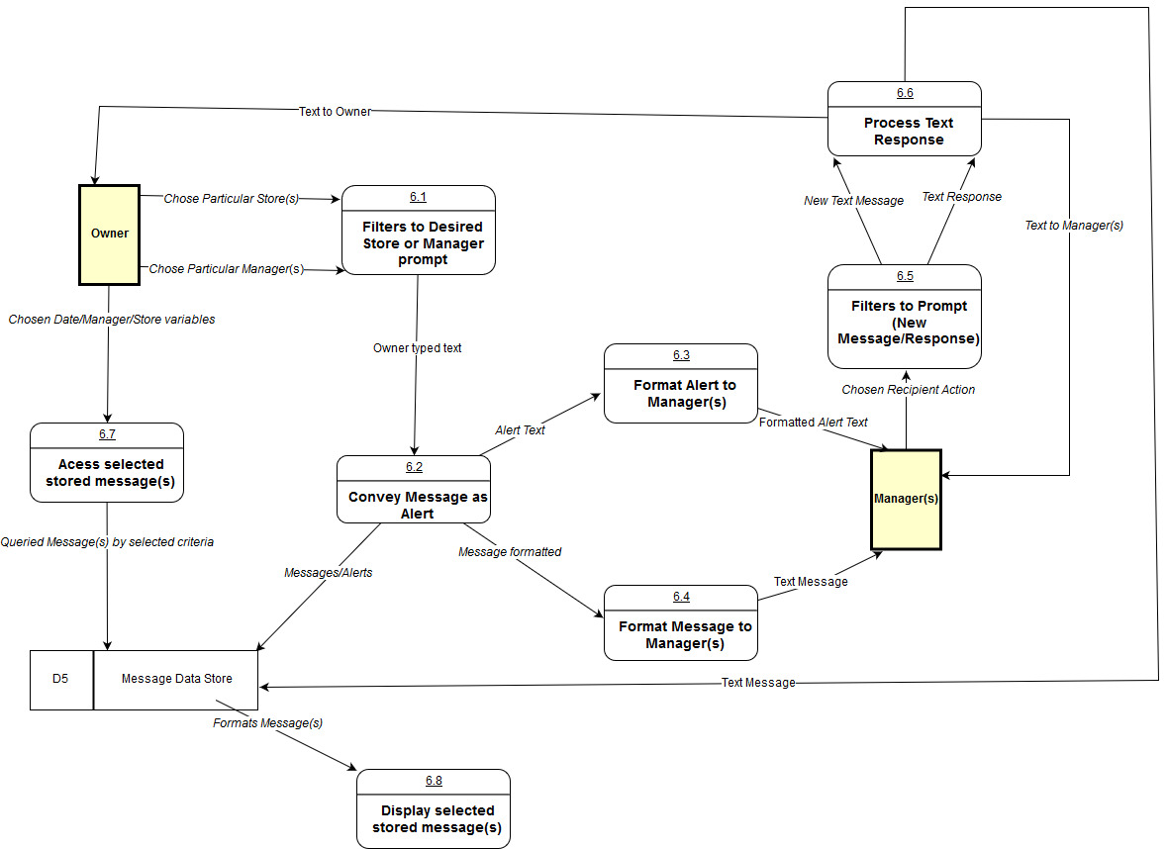

**Figure 3.9 Child Diagram 7**

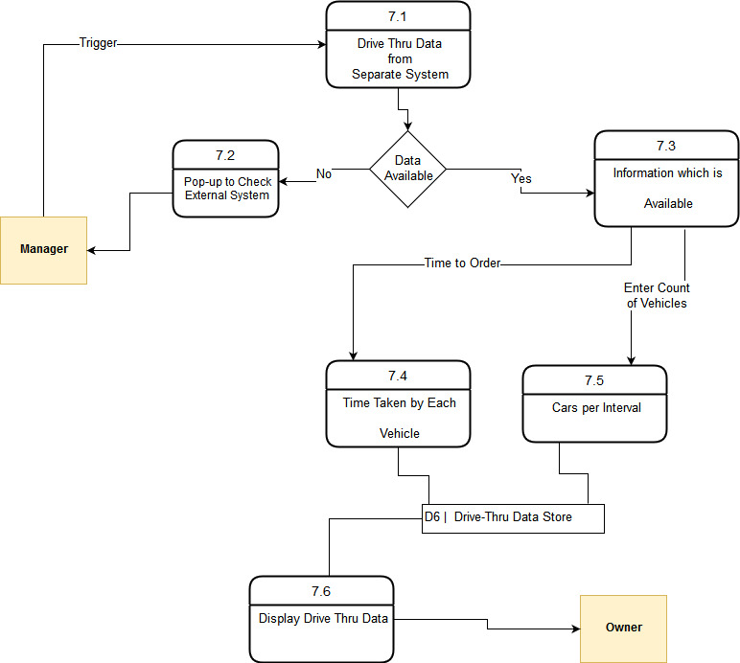

**Figure 3.10 Child Diagram 8**

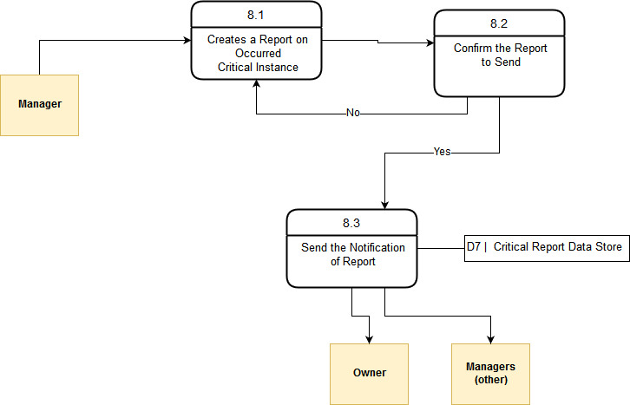

**Figure 3.11 Child Diagram 9**

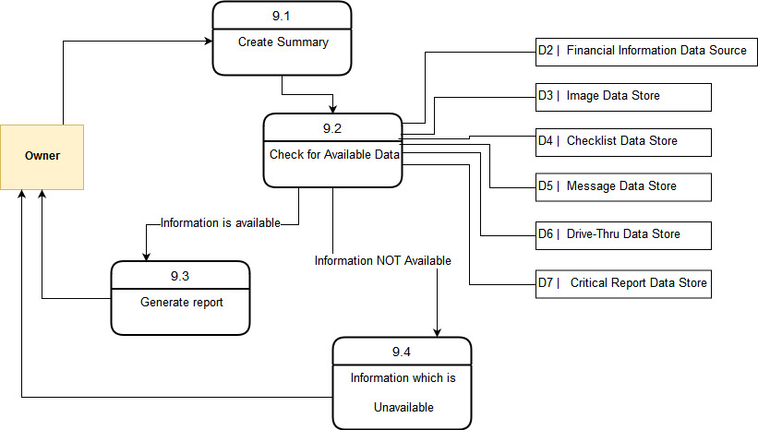

**Text Definitions**

**1. Processes**

1. Create Account:-

* Allows manager/owner to create an account with a username & password

2. Log-In:-

* Manager or owner needs to enter credentials to access system

3. Input Financial Information:-

* Allows user to add the financial information sales, labor percentage periodic

4. Upload Photos:-

* Allows user to upload image of a product or area in a restaurant

5. Create To-Do Checklist:-

* Allows user to create/access checklist to complete & manage separate tasks

6. Message Managers:-

* Users communicate with other managers using the system in order to complete a certain task

7. Store & Display Drive-Thru Data:-

* Allows users to enter times and number of cars per interval that go through the drive-thru

8. Create Critical Reports:-

* Allows creation of reports on all the text and critical instances that occur in each restaurant

9. Display Summary Reports:-

* Allows owner to view summary report of other users’ entered data and completed assigned tasks

**2. Entities**

1. Manager:-

* Managers of the restaurant check Daily Food Excellence Audit, Rush-Readiness Checklist, photo uploads for products, and upload business numbers such as sales, labor, and inventory.

2. Owner: -

* The business owner log onto the app and complete their daily tasks in an organized comprised manner. Monitors manager activity

**3. Data store**

1. D1 login credential datastore:-

* Datastore that holds information about Log-In such as username and password.

2. D2 Financial Information Data Store:-

* Datastore that stores user’s financial information such as sales and labor percentage periodic

3. D3 Image Datastore:-

* Datastore that stores images that Users upload from their device to the system.

4. D4 Checklist DataStore:-

* Datastore that stores checklists based on Users input for each task that are then put into a to-do list.

5. D5 Message DataStore:-

* Datastore that stores messages that are sent to another user

6. D6 Drive-Thru DataStore:-

* That stores User inputs data into system that was recorded from the other system that collects drive-thru data

7. D7 Critical Report Data Store:-

* Stores Users written report in system that will be sent to desired recipient.

**4. Data Flow**

1. Account ID:-

* Have a username and password that the user needs to enter each time they want to log in

2. Account Creation Form:-

* Users create an account with unique username and password to be used to validate credentials every time the user logs in to the system

3. Log-in Credential:-

* Users enters the same unique username and password that they previously used to create his or her account

4. Financial Information:-

* Information sales and labor percentage periodic are stored

5. Approved Credential:-

* Users can access the system’s features

6. Valid Credential:-

* System checks if the user name and password is validated or not.

7. Image File:-

* Users provide a visual representation of a product that needs to be reported to the owner.

8. Checklist

* System displays a checklist containing separate tasks that the user can mark under “to-do” or “completed”

9. Drive-Thru Data:-

* Displays drive-thru data separated by time intervals and days.

10. Message Data:-

* User inputs a message that can be sent to another user

11. Checklist Data:-

* System displays a checklist containing separate tasks that the user can mark under “to-do” or “completed

**Entity Relationship Diagram**

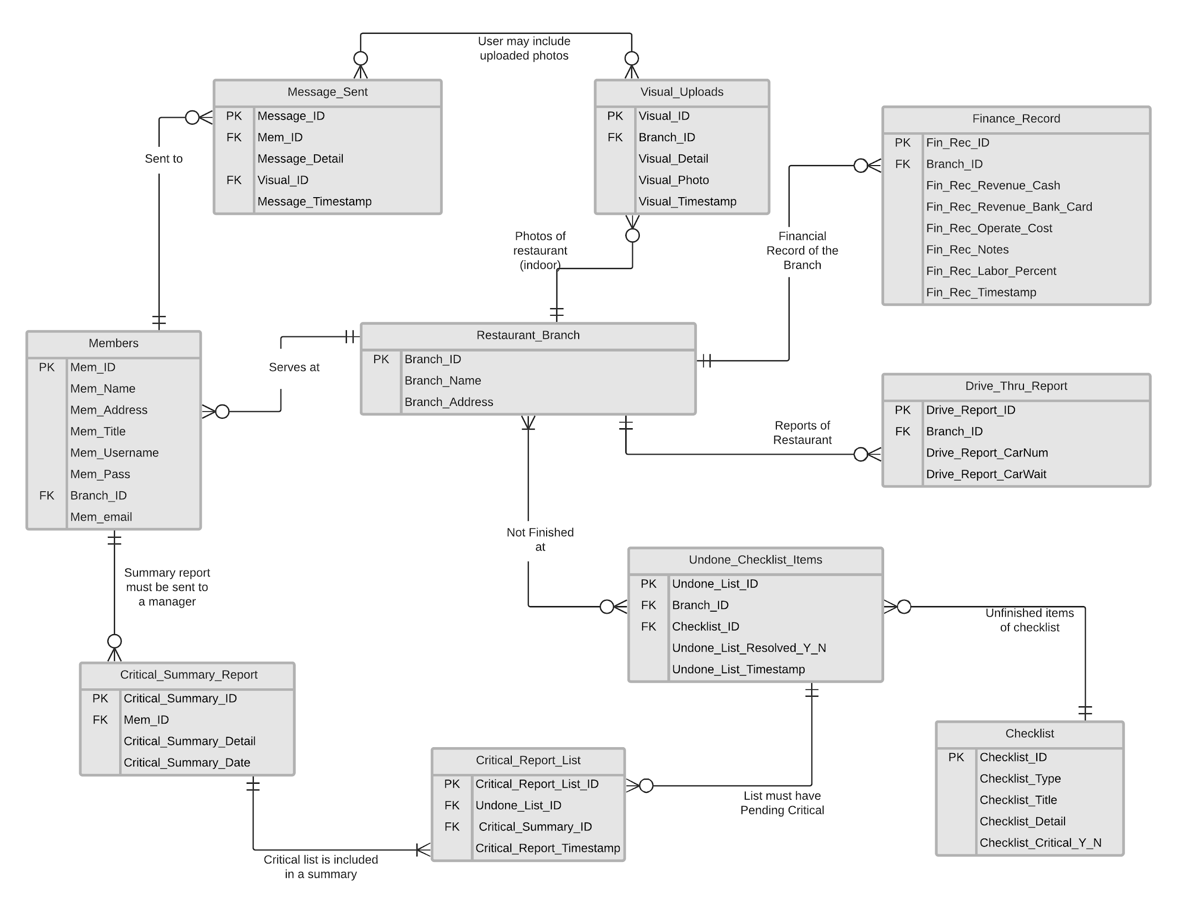

|  |  |
| --- | --- |
| **Entities** | **Relationship** |
| Members - Restaurant_Branch | A Member must have a restaurant’s branch, where he/she works at. |
| Restaurant_Branch - Finance_Record | Financial report of restaurant branch will be filled at the end of day. |
| Restaurant_Branch - Drive_Thru_Report | Drive thru report is filed for each restaurant at end of day. |
| Restaurant_Branch - Visual_Uploads | Photos of completion is uploaded for every restaurant. |
| Restaurant_Branch - Undone_Checklist_Items | Every unfinished item from checklist in a restaurant is saved so that the owner could see it. |
| Undone_Checklist_Items - Checklists | Undone checklist must have item from checklist, that was not finished. |
| Critical_Summary_Report -  Members | Critical summary consists every member’s critical task, which was not done. |
| Critical_Summary_Report - Critical_Report_List | Critical list has multiple items for summary and summary must have at least one list item. |
| Critical_Report_List -  Undone_Checklist_Items | Each item in critical report list must have the undone item. However, every undone item may not be included in critical list. |
| Message_Sent - Members | A message is sent to a member and a member can receive multiple messages. |

**Alternative Matrix Descriptions**

Since our application is custom built, the alternative situations we needed to examine were storage. In our research, we looked at 3 different ways to store our application and went about selecting the best option through various metrics such as cost, technical issues, and scalability.

**Alternative 1: Personal Local Server**

* The idea behind using a personal local server comes from discussions during the design process about streamlining the application and allowing the stakeholder to have a more personal approach to the application usage. While the stakeholder is more technically incline, they have no real experience with AWS so opting for that option means a delayed phase after hand-off since they would need to adapt to the AWS environment. Another issue with the personal server is the cost, while the application itself is not compute intensive, there still is reason to purchase a personal separate server as opposed to using a personal computer. The costs with this option is the highest amongst the three and requires some level of tutoring to work with the Microsoft Server Essentials OS, which is another high cost option. The research we did showed a server tower for $1,300 that had, **CPU -** Xeon E3-1220V6 / 3 GHz, **RAM -** 8 GB, **HDD -** 1 TB along with 4 extra HDD space and hot-swappable bays, but this approach would mean we still have to spend another $300 for an OS and more HDD, which should honestly be upgraded to SDD for faster read/write services. The only true positive about this solution is that the server is localized and allows for more personal interaction between the stakeholder.

**Alternative 2: AWS Service**

* The option that seems to be the top choice amongst our team. The AWS service is well known and widely supported to various areas of IT business so there is no shortage of troubleshooting options should there be any issues with maintenance for the stakeholder. The other benefit is that the service is entirely scalable so should the features that are initially chosen seem to be too little or too much, the stakeholder has the option to change it at will. The service also comes with storage, SQL support, and a bunch of security/redundancy capabilities that allow for safer storage in the long run. The negatives are the cost, though much cheaper than option 1 but more expensive than option 3 and the learning curve that will come with using AWS for the stakeholder and team.

**Alternative 3: Aggregate Web Hosting Service (GoDaddy)**

* The third option we came up with is hosting the application through a domain hosting service like GoDaddy. This is a service that no one on the team, nor the stakeholder has experience with. This option means that this application would have to follow a build allowed by GoDaddy, which may or may not be a viable option due to requirements set forth in the beginning of the project. There seems to be no scalable option either with the application or web hosting so that is another issue that fails compared to the other two options. The price point is the highlight of this option though as it is the cheapest of the alternatives. There seems to be no option for some sort of DB option, which is an issue that would need to be looked into before using this service. So while this alternative is the cheapest, it seems to be the least appropriate for our project.

**Alternative Matrix**

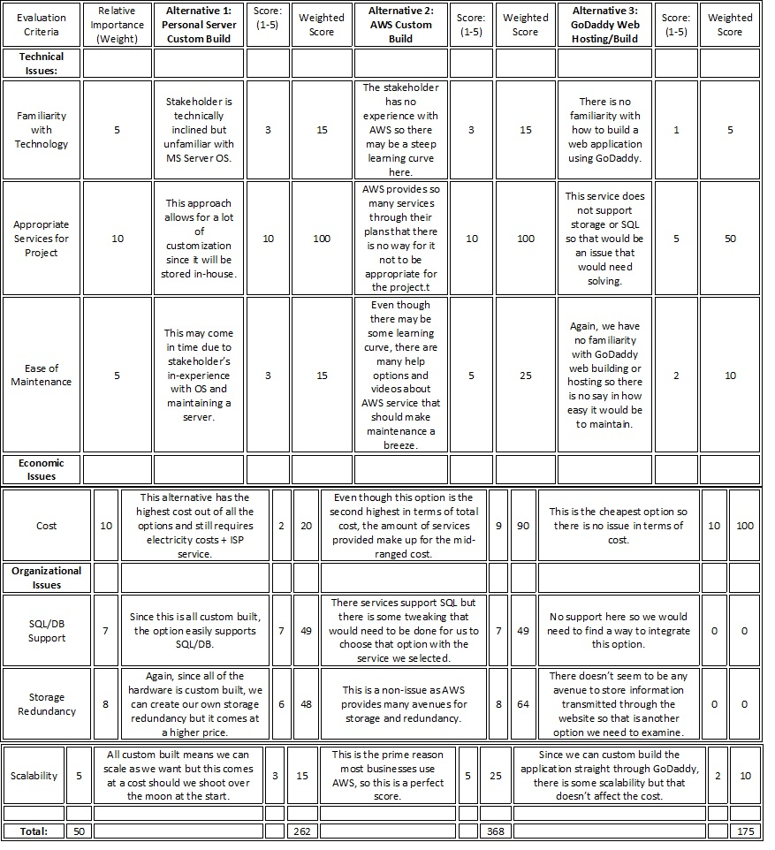

**System Architecture Alternative Matrix:**

|  |  |  |  |
| --- | --- | --- | --- |
| **Requirement** | **Server based** | **Thin client-server** | **Thick client-server** |
| **Operational requirement** | | | |
| Technical Requirement | ✔ | ✔ | ✔ |
| System Integration Requirement | ✔ |  | ✔ |
| **Performance Requirement** | | | |
| Speed Requirement |  | ✔ |  |
| Capacity Requirement |  | ✔ | ✔ |
| Availability/ Reliability Requirements | ✔ | ✔ | ✔ |
| **Security Requirements** | | | |
| User Authorization Requirements | ✔ | ✔ |  |
| Access Control Requirements | ✔ | ✔ | ✔ |
| Encryption/Authentication Requirements |  | ✔ | ✔ |
| **Cultural/Political Requirements:** | | | |
| Legal Requirements |  | ✔ |  |
| Popeyes Policy | ✔ | ✔ | ✔ |
| Popeyes Ethic Policy | ✔ | ✔ | ✔ |

**Operational Requirements:**

1. Technical Requirement

1.1. With a thin-client server, the technical Requirement would have an easier time integrating with a cloud/internet platform because of low maintainability requirements.

2. System Integration Requirement

2.1. Popeyes/ Managers app integration, we decided a thin client-

server would be best suited because of having an easier time integrating with existing Microsoft Office software and basic camera function will reduced the cost savings from initial installation.

**Performance requirements:**

1. Speed Requirements
   1. Speed performance with thin client server architecture is more appropriate because software has high performance and it will be cheaper and easier to install.
2. Capacity Requirements
   1. Capacity requirements under thin client-server architecture would be more suitable due to higher scalability options and the system supporting an unlimited number of users. However, a thick client-server would also work because of not having an extremely large user base
3. Availability/Reliability Requirements
   1. Under a thin client-server, users would have higher reliability from multiple servers and as well as from a thick client-server or server-based architecture. However, this requirement mostly depends on the hardware and operating systems used. So, it can be either server-based, thick or thin client-server can be used.

**Security Requirements:**

1. User Authorization Requirements

1.1 User authorization should be done on server-based architecture because better of security through elimination of authorization through software, which is more prone to widespread attacks.Thin client server doesn't have effective and reduced security.

1. Access Control Requirements:

2.1 Having access control on server-based architecture would decrease chances of unauthorized users accessing the system due to an extra layer of security.

1. Encryption/Authentication requirements:

3.1 Encryption/ authentication will be done on the thick and thin-server due to advanced internet security standards used in today's cloud/internet platforms.

**Cultural/Political Requirements:**

1. Legal Requirements

1.1. Under thin client, changing legal requirements would be easier to change in the presentation logic and to disable or enable features.

Popeyes Policy Requirements

2.1. Under thin client, the changing of UMBC’s policies may be updated easier in the presentation logic as opposed to having to update every client device.

Popeyes Ethics Policy

3.1. Under thin client, the changing of popeyes ethical policies may be updated

easier in the presentation logic as opposed to having to update every client device.Either thick, server based can work in this situation.

**System Architecture Decision**

After we have appointed check mark toward the system architecture designed. We have found that our strongest choice would be a thin-client server. A thin-client server is the most cost-saving option for the other system architectures. It is also very simplified management system. It is easy to manage the system and utilize it with many different software options which can help to simplify the use of the system. It is centralized and simplifies the use of the system. It is centralized and simplifies backup of client access devices. In addition,a thin-client server has an enhanced security that is critical for our system. The system will store user’s information, and it is a top priority to keep this protected and secured. One main problem that comes with a thin-client server is its centralized nature, which can result in loss of data if the server fails. The physical security is also at risk. However, a thin-client serve will help owner to increase productivity as it has a quick start up and enables flexibility without needing a specialist to start up the system. After we compared the check mark with reasoning we have decided that thin-client is great option for your client versus thick-client and server based.

**Overall Team Matrix (AWS Custom Build)**

**\*\*Due to some time constraints and in-experience with AWS, the demo that will be shown in-class will be hosted through GL servers hosted at UMBC to meet the requirements. The end plan to host the completed application will come through AWS but until then any demos will be strictly hosted on a GL server.**

As a team we decided to go with the AWS custom build design, as it provides the most bang for our buck. The AWS service allows for us to custom build the application to the stakeholder’s requirements which allows us to customize features that may not be available with other options, such as the GoDaddy route. Also, AWS is entirely scalable from features to cost, meaning that should the option we chose with EC2 a1.large be too much hardware for our needs, the system owner can scale down and end up saving money. The EC2 service also allows for SQL support, meaning that we can create a DB for easy storage and look-up.

AWS is also a widely used service across many business enterprises which means that should the system owner ever find themselves with an issue they cannot solve, there are a monumental amount of help services that they can look to which also includes Amazon’s own help desk service. In terms of storage redundancy, they also provide that feature because that was a requirement from the stakeholder to keep information for extended periods of time. The cost aspect, about $263 not intaking for some added features we will need to look into, is a very small sum for the service that is provided. This is a great meeting point in terms of cost and benefits, as it is not the cheapest option but provides the one of the highest avenues for customization.

The AWS solution seems to be the perfect way to integrate the web application to the stakeholders needs at the moment and still allow for scalable options should he require more features in the future. The only issue, again, is that the stakeholder is unfamiliar with the AWS technology so at hand-off there will be a steep or medium learning curve for them. The other alternative of custom building the application and strictly using GoDaddy as a domain service is also enticing but the issue with GoDaddy comes when integrating SQL and storage features. There is an even steeper learning curve when trying to integrate all of those features that makes the lower cost option less attractive. The highly customizable features of an in-house server is great but comes at a large cost. AWS is the best option when considering all of these factors since it sits right in the middle of what this project requires.

**Figure 4.4 Hardware and Software Specification**

|  |  |  |  |
| --- | --- | --- | --- |
|  | Client | Web Based  Server | Database Server |
| Software | Windows 10 | Linux | Oracle Database |
| Hardware | * 500 GB memory device * Intel Core i7-920 * 22-inch LED Monitor | * 500 GB disk drive * Intel Xeon Platinum 8000 | * 1-TB disk drive * RAID |
| Network | * 1 Gbps bandwidth * Popeyes Wifi | * GL Server | * GL Server |

**User Interface Design**

Login page:

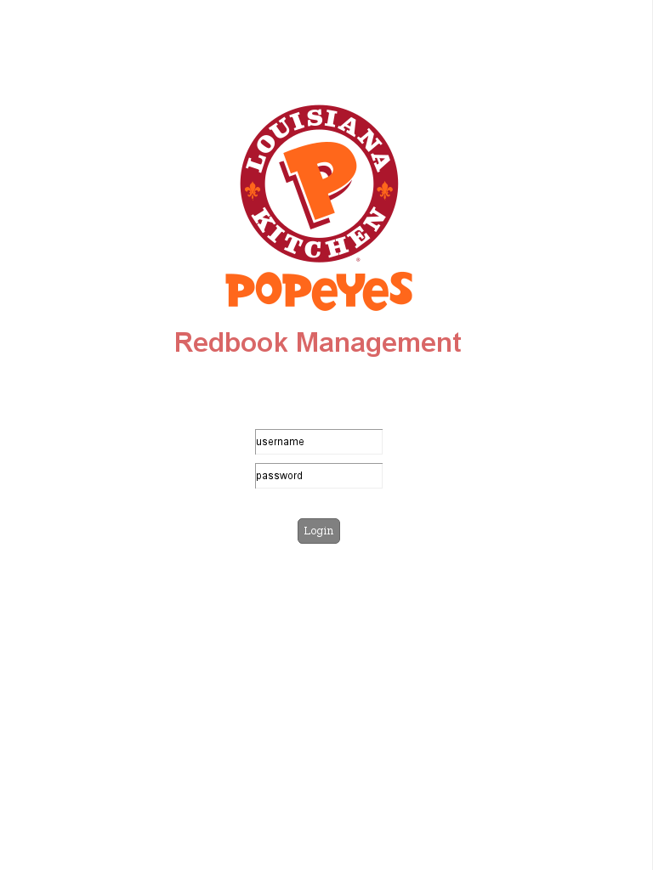

Owner Page:

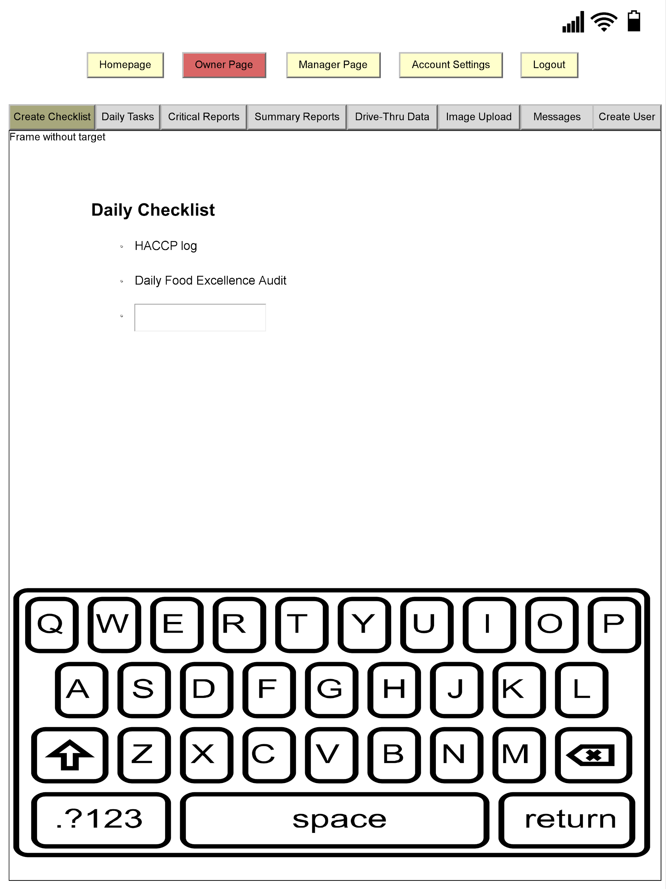

Manager Page:

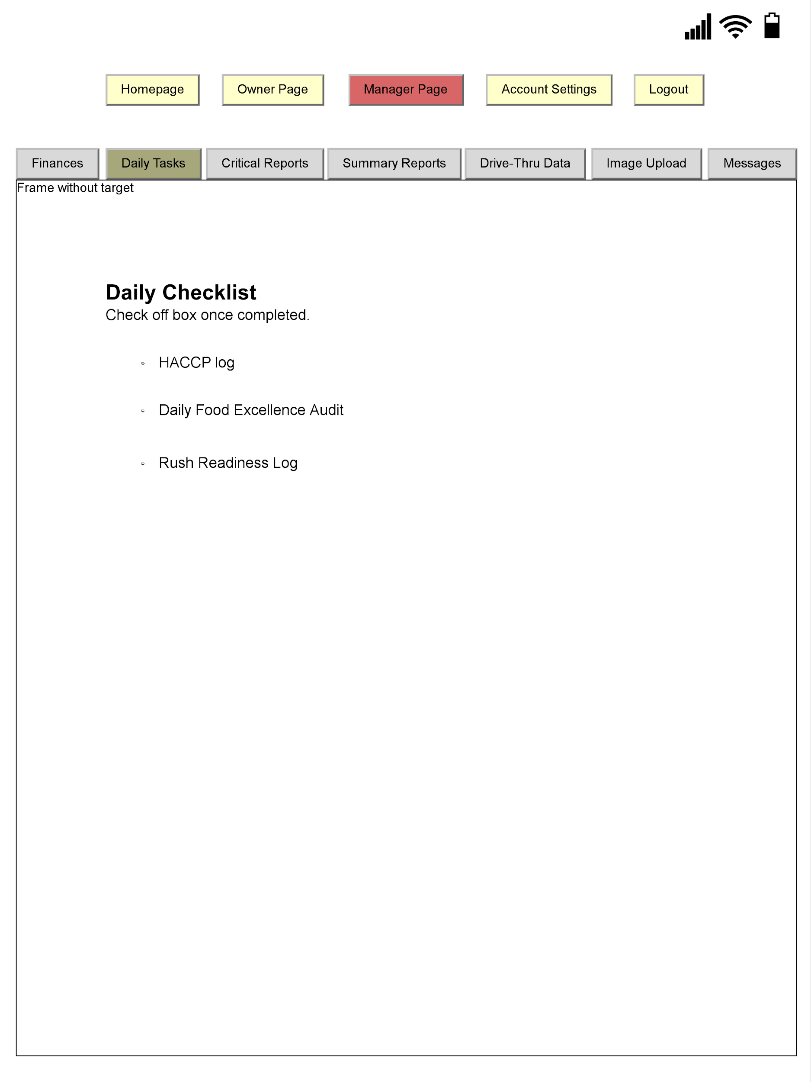

**Interface Standards**

The interface should allow users to create and mark off completed checklists. Each page is uniquely tailored to the type of user that is accessing the webpage. For instance, the owner is the only one that has access to create a new checklist. Additionally, the owner will be able to uniquely type in different tasks on the tab labeled “Create Checklist” while the manager will be able to mark off the tasks that has been completed on the “View Checklist” page. This allows both the manager and the owner to keep track of their duties. Additionally, once a manager completes a task, all tasks will be listed on a separate tab labeled “Daily Tasks”. The input of this webpage is how the owner is able to add a list of tasks for the manager to complete and how the manager is able to make adjustments to the list depending on which task was completed. The output is a separate list of tasks that will be created automatically by the system as shown on the “Daily Tasks” page. All information is stored on a cloud. Each page should be easy to navigate as all headers and links are uniform and consistent in placement, size, and shape. Furthermore, all users should be able to know which page they are currently on because the tabs at the top will be highlighted in red to stand out. Additionally, the page is very clean without a lot of clutter that would create confusion while navigating. The top of the screen is used as a navigation area, the content is located in the middle and the work area is located at the bottom. This is consistently shown throughout all pages. Colors and patterns were also chosen carefully in order to prevent any further confusion or inability to have certain objects on the page stand out when needed or necessary.

**Program Design**

Login Page:

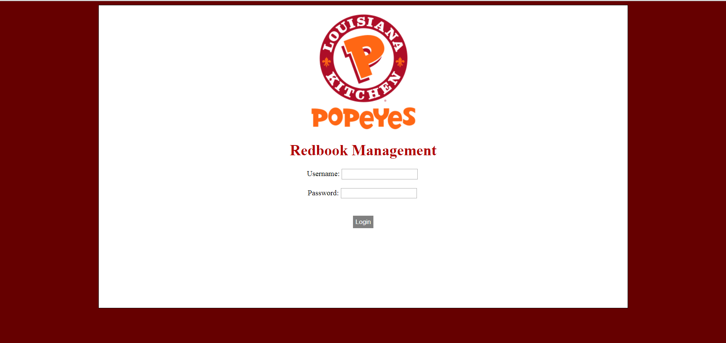

Create Checklist (Owner Page):

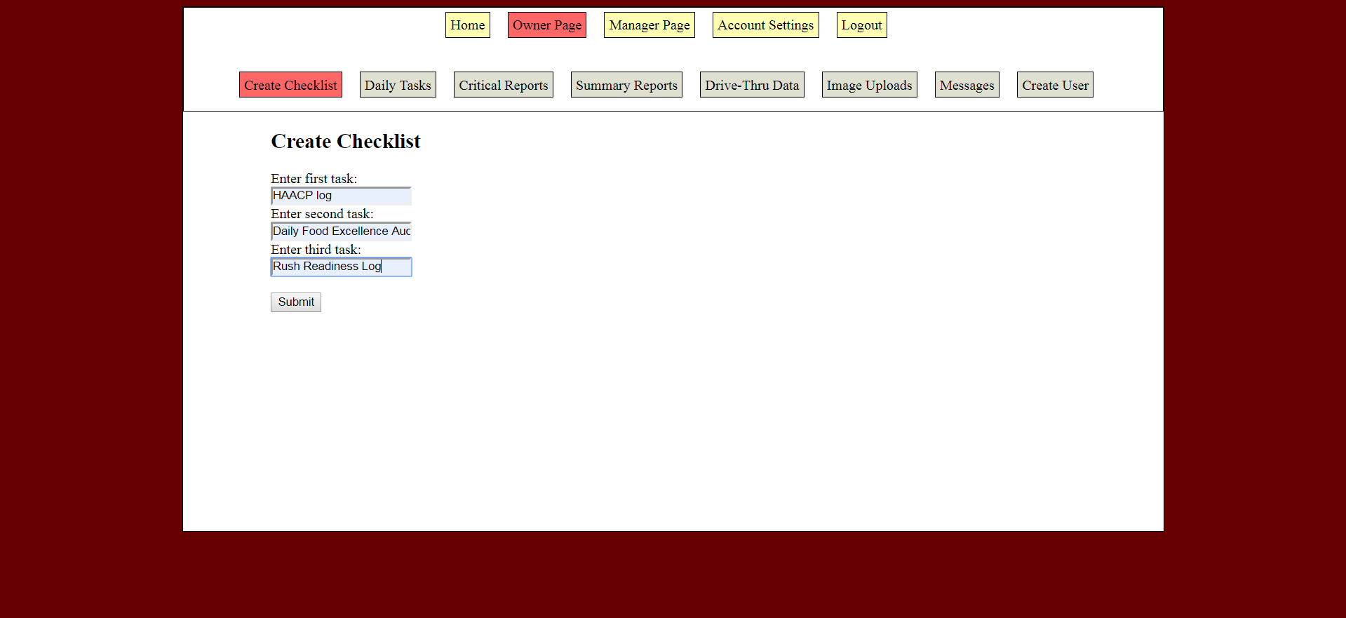

View Checklist (Manager Page):

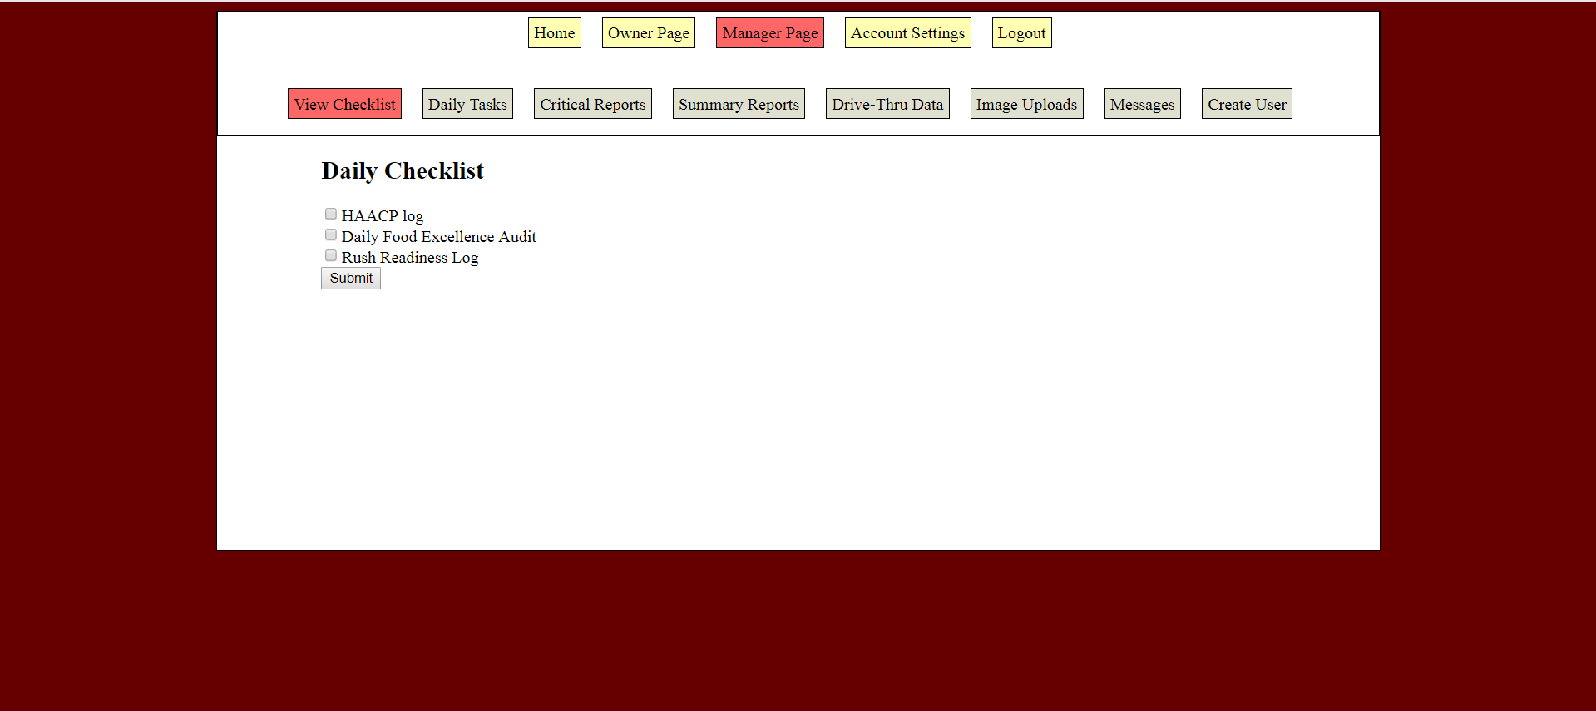

Daily Tasks Completed (Owner Page):

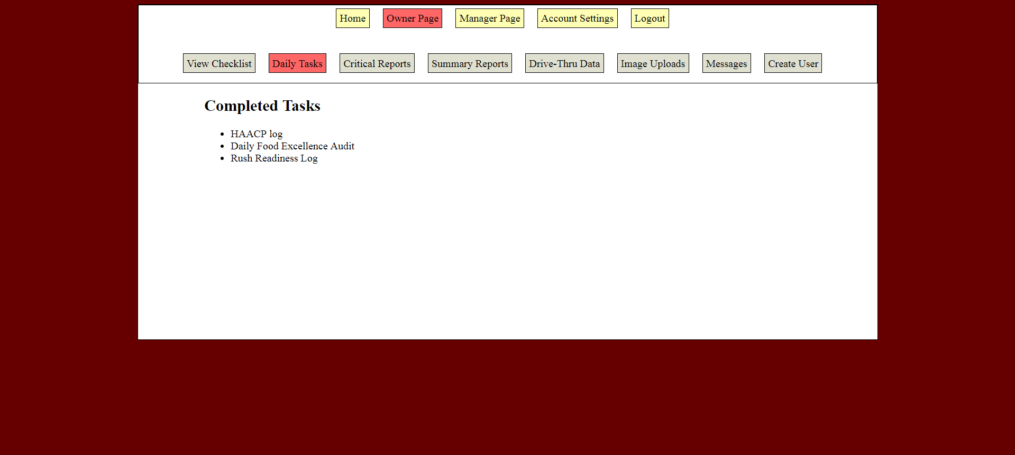

**System Requirements**

The main aim of this system requirement report is to establish how the stakeholders, managers, and other team members are integrated to head in one direction with a purpose of accomplishing the objectives of Popeyes restaurant. This systems requirement will include product documentation and process documentation. Product documentation, the product scope consists of the system and the end users analysis. This document highlights all the requirements of the system. Describes what the system should do depending on the business rules and the user story description. The roles and responsibilities of team members are defined including Popeye's owner, team members, and stakeholders. This app will enable Syed Abid Iqbal (owner) to evaluate the restaurant process and to make necessary improvements to the restaurant and to ensure that all the financial information is done under a single platform. Managers and the workers at popeyes restaurant can upload data, edit and share any information that is relevant in time. Furthermore, the system is designed in a way that it will allow the team members to manage the HACCP log that is necessary for the consciousness of the customers' health.

The system also allows the admin to make updates on employees’ information in real time and their contribution to the business. The team goal and the business goal are to provide food products in an effective manner considering the health of the customers and also make profits. The system requirements are set to explain the easiest way to which the application will help in bringing efficiency in Popeyes restaurant. The system requirements ensure quick data entry and also make user logins easy and reliable. The system requirement also provides the quality assurance of the app, the security measures and the design patterns of the system

**Team Experience**

In many aspects of life, one is often required to play a role as a team player. Different personalities affect the way they approach teamwork and related activities; some individuals prefer to take responsibility for their work and a particular form of doing things. Our team consists of eight members, and we were able to learn several aspects when working together on our project. Each member of our group was assigned various tasks, and this prevented a person from doing copious amounts of work: there was that team confidence that each member will accomplish his or her part of the task and in the needed time. The group had experience both on the project and as a team.

At first, we have actively engaged in the planning the management app which involved systems request and feasibility analysis for both the organization and the management app. The main aim of this part of our project was to study how the management can use this app to allow us to determine how the business conduct its activities so that we can come up with an app that meets the needs of the company. During the planning phase, we identified the need for a new management system that would achieve the objectives of the organization. Our group conducted a feasibility study and came up with a preliminary plan that provided solutions to particular situations. In the second, another experience was achieved through system analysis and requirements. In this stage, the major challenge experienced was identifying the precise functional requirements and needs of the end users. However, we resolved this problem by conducting a study to analyze the best system requirements and needs for the company that would use our app.

After identification of system requirements and needs, the team engaged in designing a system that consisted of specifications, features, and operations that will be compatible with the specific system requirements. At this stage, the major challenge experienced was the fact that we experienced some requirements that were not testable and in cases when they were testable the results indicated that they were not responsive to the proposed system design.

The team was also involved in the development of the management application system; this is where the real work began. The development of our app involved modeling the application system and making relevant changes for the app to perform its stated functions. Establishing a public profile was a challenge; there was a fear of doing it poorly which would be a significant wastage of time. However, we resolved this by understanding what was required for our management system to work correctly.

Process modeling and system requirement are among the critical part of our project that presented constant project related problems. Problem-solving is one of the best team experiences that were noted by all members by interacting with each other. The team members learned to be attentive to every detail in the projects; not only was it beneficial to the project but also the outside life of the team members. Every member of the group seemed to be moving in the same direction just fine. The members of our team were also able to acquire skills and the functions of working with different personalities, and each member realized how teamwork was an influential factor that contributes to team success

**Project Plan**

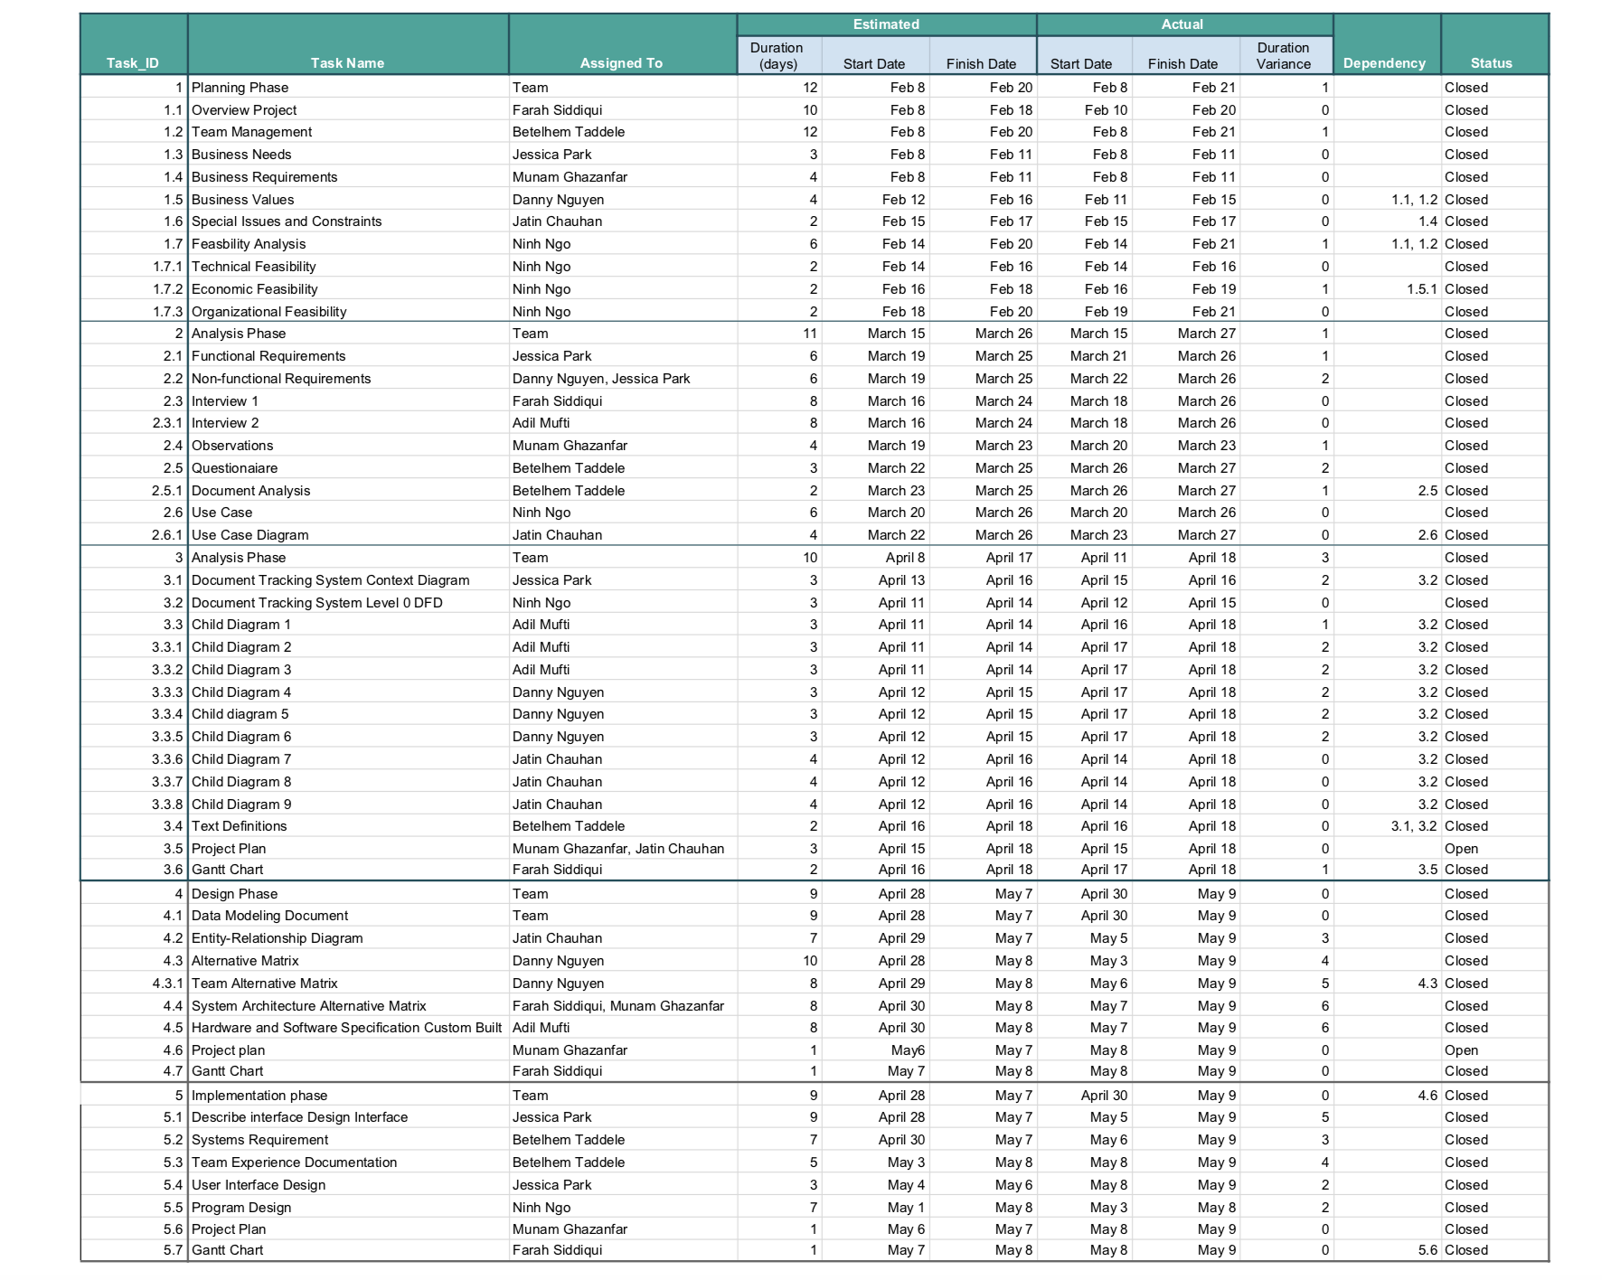

Gantt Chart

